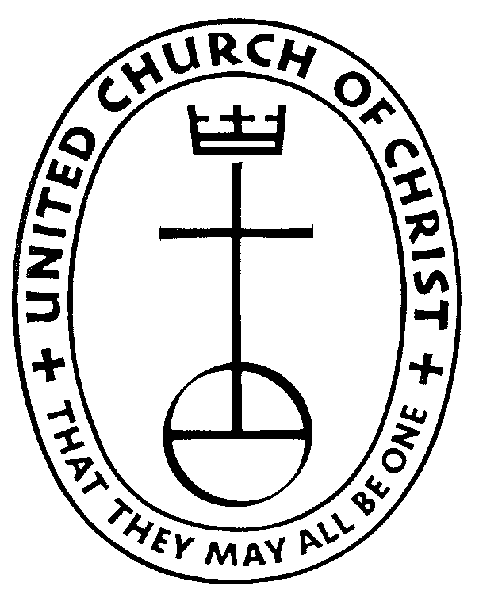
Zion United Church of Christ
113 1st Street, NE Waukon, IA 52172 563-568-3589
zionuccwaukon@gmail.com

Zion UCC Scholarship Application Requirements
and Instructions for completing the Application

Requirements to be eligible to apply for a Zion Scholarship:

- Applicant must be a full time student
- Applicant must be a member of Zion United Church of Christ
- Applicant must be pursuing an undergraduate degree or attending seminary school
- The Zion UCC Scholarship will only be awarded a maximum of 4 times

Instructions for completing the Zion UCC Scholarship Application:

- Complete the entire application
- Deadline to submit completed application is May 31, 2026.
- Place your completed application in the attached envelope. Make sure you seal the envelope and write your name on the outside of the envelope where instructed.
IF YOU ARE FILLING OUT THE ONLINE APPLICATION, please email all forms to: zionuccwaukon@gmail.com
- You will need three (3) references; only one of which can be a teacher. Provide each reference with a copy of the Scholarship Reference Evaluation form OR our website information as well as a return envelope OR our email address.
- If you have any questions, please feel free to contact any one of the Education Trust Committee members. Committee members are Gail Prestemon and Cathy Buhl.

